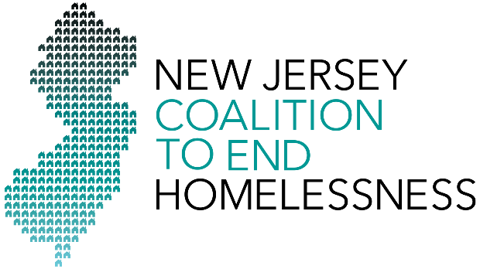
www.njceh.org

To donate to the New Jersey Coalition to End Homelessness, please fill out this form and mail it with your check to:

Attn: Jeff Wild, Executive Director
NJ Coalition to End Homelessness
c/o Lowenstein, Sandler LLP
One Lowenstein Drive
Roseland, NJ 07068

Please make checks payable to NJ Coalition to End Homelessness.

Name: _______________________________________________________________________________

Street Address: ________________________________________________________________________

City, State and Zip Code: _________________________________________________________________

Organization (optional): _________________________________________________________________

Job Title (optional): _____________________________________________________________________

Email Address: ________________________________________________________________________

Phone: __________________________________________ Home/Work?

I would like to make a contribution of: $_____________._________

This contribution is in honor of: ___________________________________________________________

How did you hear about the Coalition? _____________________________________________________

Additional Comments: __________________________________________________________________

_____________________________________________________________________________________

Thank you for your support!

